**Drone in Agriculture**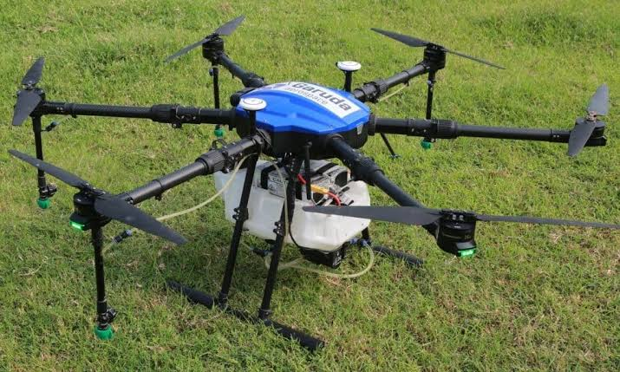

**SUBMITTED BY**

**E. SIVARAMAN**

**Pudhukuraipettai,**

**Vriddhachalam (Po & TK),**

**Cuddalore DT, Pin: 606003**

**Mobile: 9655358325**

**2024-2025**

**Project Description**

**Introduction**

A drone refers to an aerial vehicle that receives remote commands from a pilot or relies on software for autonomous flight. Many drones display features like cameras for collecting visual data and propellers for stabilizing their flight patterns. Sectors like videography, search and rescue, agriculture and transportation have adopted drone technology. Basically, I come from a farmer's family, so I thought about how to use drones on farms. Then I searched on Google and found more details about drone features. After that, I applied the knowledge in the field.

**Here are some key benefits of using Agri Drones**

* **Manpower:** In our village, most landlords are facing manpower issues because of the government's 100-day work scheme, so many tasks are not being completed on time.
* **Cost Savings:** Agri Drones can help farmers reduce costs in multiple ways. By identifying specific areas in need of intervention, farmers can apply treatments only where necessary, reducing the use of chemicals and optimizing inputs. Drones can also minimize the need for manual labour, making operations more cost-effective.
* **Safety and Risk Reduction:** Using Agri Drones reduces the need for farmers to physically access challenging or hazardous terrains. Drones can fly over rough or inaccessible areas, reducing the risk of accidents or injuries. Additionally, drones equipped with thermal imaging cameras can identify potential fire risks in agricultural areas.
* **Increased Productivity:** With the ability to cover large areas quickly and efficiently, Agri Drones can significantly increase productivity. They can perform tasks such as mapping, planting, spraying, or monitoring in a fraction of the time it would take using traditional methods, saving labour and resources.

**Our Drone on Field**

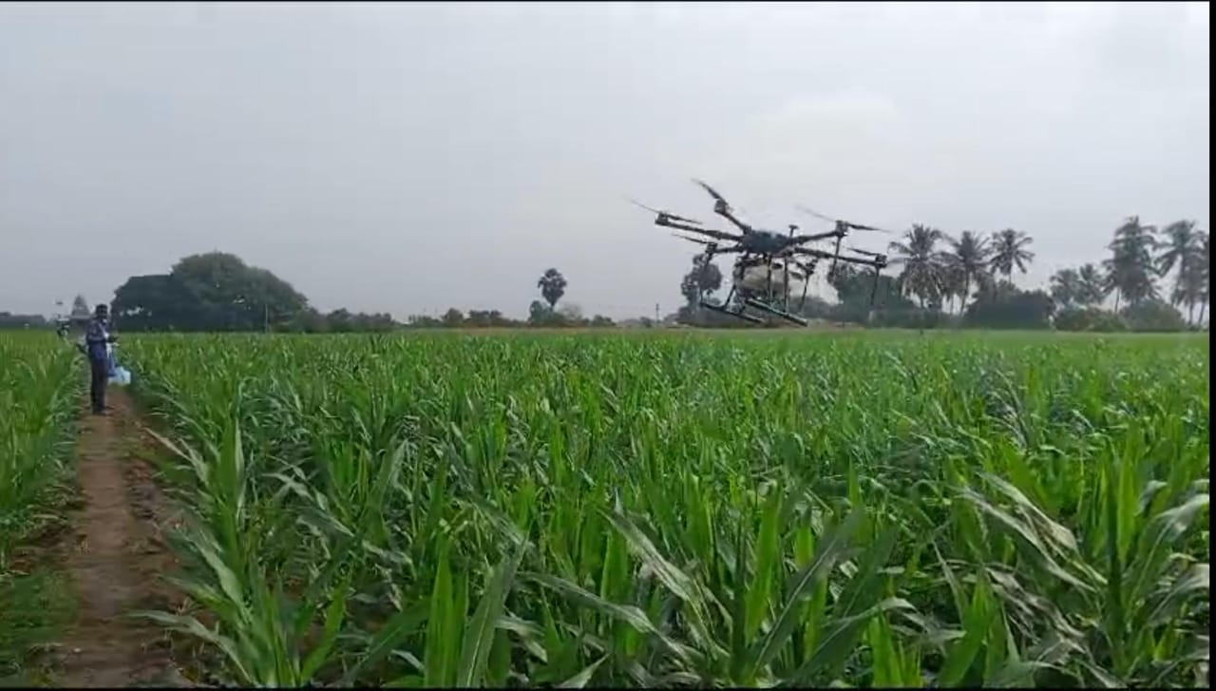

**Crop:** Popcorn

**Location:** Aavatti

**Area:** 6.3hectare

**Duration:** 90min

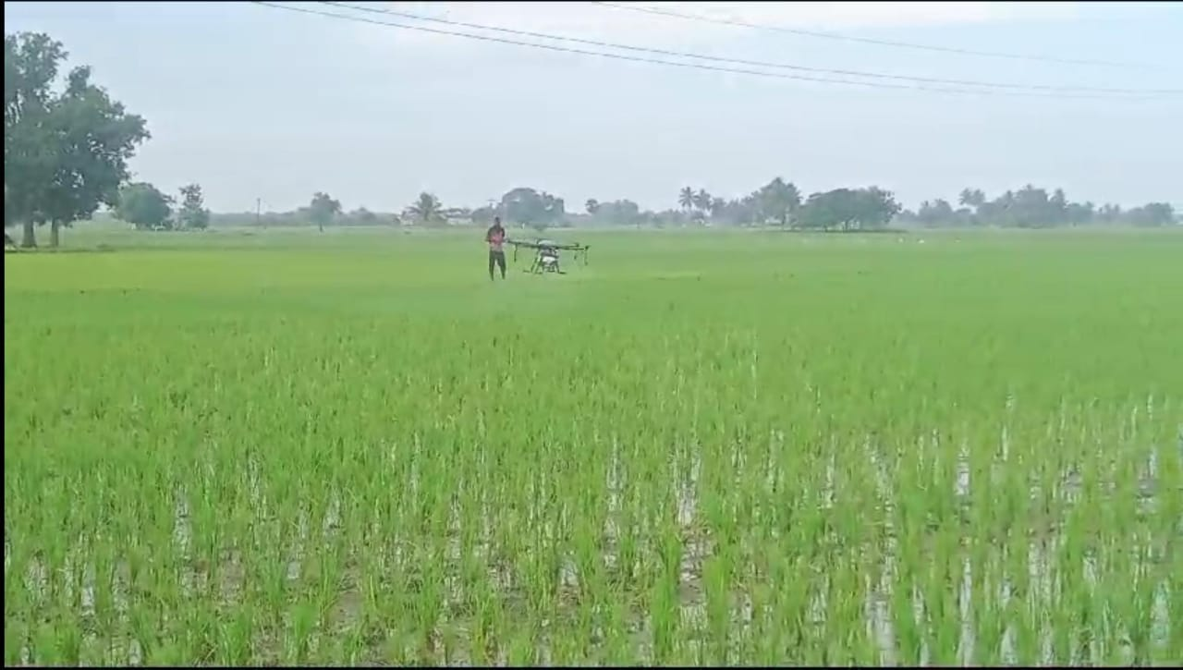

**Crop**: Paddy

**Location**: Sathukudal

**Area**: 4 hectares

**Duration**: 60min

**Crop:** Groundnut

**Location:** Pudhukuraipettai

**Area:** 2hectares

**Duration:** 30min

|  |  |
| --- | --- |
| **Advantages** | **Disadvantages** |
| Drones equipped with advanced imaging and sensor technologies can precisely target specific areas of a field that require treatment. They can identify and apply treatments only where necessary, reducing chemical usage and minimizing off-target effects. | Traditional spraying methods often lack precision and can result in over spraying or uneven distribution of chemicals. This may lead to wastage, environmental contamination, and potential harm to non-targeted areas or organisms. |
| Drones can cover large areas quickly, especially in open fields, due to their ability to fly autonomously and follow pre-programmed flight paths. They can accomplish spraying tasks efficiently, saving time and labour. | Traditional spraying methods typically involve manual or tractor-mounted sprayers that require slower movement and more time-consuming application. It may be less efficient, especially in large or uneven terrains. |
| Drones can access difficult or hazardous areas without requiring farmers to physically enter those zones. This enhances safety and reduces the risk of accidents, especially in areas with rough terrain or obstacles. | Traditional spraying methods often require farmers to physically navigate through challenging or hazardous terrains, potentially exposing them to risks such as falls, exposure to chemicals, or equipment accidents. |
| While the initial investment for Agri Drones may be higher, they can lead to long-term cost savings. Drones enable targeted treatments, reducing the use of chemicals, optimizing resource allocation, and minimizing labor requirements. | Traditional spraying methods may involve higher chemical usage, especially if treatments are applied uniformly across an entire field. It may also require more labor and time, leading to increased operational costs. |

**Project Profile (Financial)**

|  |  |
| --- | --- |
| **Drone** | **01** |
| **Battery** | **04** |
| **Chargers** | **02** |
| **Cost of Project** | **7,60,000** |
| **Bank Loan** | **4,50,000** |
| **Margin Money** | **3,10,000** |
| **Financial Indications** | **30,000 / Month** |
| **Interest Rate (% per annum)** | **9** |
| **Repayment Period** | **3 years** |